department of computer technology

**synopsis**

**on**

**information sharing in android using bluetooth**

**submitted by:**

**dhanjay sathe**

**chetan chopade**

**ritesh j. chetwanI**

**gaurav g. timkhede**

**under the guidance of**

**mrs. gauri chaudhary**



YESHWANTRAO CHAVAN COLLEGE OF ENGINEERING

hingna road, WANADONGRI, NAGPUR-441110

year 2012-2013

PROBLEM DEFINITION

To generate an user interface which provide an “effective” content sharing mechanism in android for Bluetooth users so that user can access the various services available at public places without any actual interaction with the respective administrators. Using this interface user must able to fire their queries during interaction and get proper answer from administrator instantly.

**aBSTRACT**

Nowadays, there are various services available at public places such as colleges, hospitals, malls, railways etc. for example, requirement of blood in hospitals, notifications in schools/colleges and so on. Normally, Users are unaware of these services so they may face many problems. To make user aware of such services, in this project we are trying to create user interface so that user can easily interact with the administrator and access such services. This interface make user able to easily and effectively communicate their respective administrator so that they should not be face any difficulties. This interface also make possible two way communication between the user and system in which any user must able to fire their queries during interaction and get proper answer from administrator instantly

**aim and objective**

**AIM:**

To create an user interface for information sharing in android using Bluetooth.

**OBJECTIVE:**

* The key objective of this project is that it should have a well-featured Dynamic user interface so that the user can easily implement and incorporate it.
* It should help to reduce user interaction with admin peoples at public places such as colleges, hospitals, mall, railways etc.
* It should be able to easily and effectively communicate their respective administrator so that they should not face any difficulties.
* An administrator should be able to Add, Update, Delete and modify the information on day to day basis so that user can easily be informed about the changes made and know their interest.
* Any user must able to fire their queries during interaction and get proper answer from administrator instantly.

**LITRATURE SURVEY**

**“Bluetooth-Based Android Interactive Applications for Smart Living”**

-By

[Johansson, P.](http://ieeexplore.ieee.org/search/searchresult.jsp?searchWithin=p_Authors:.QT.Johansson,%20P..QT.&newsearch=partialPref)  
Ericsson Corp. Res., Stockholm   
[Kazantzidis, M.](http://ieeexplore.ieee.org/search/searchresult.jsp?searchWithin=p_Authors:.QT.Kazantzidis,%20M..QT.&newsearch=partialPref);  [Kapoor, R.](http://ieeexplore.ieee.org/search/searchresult.jsp?searchWithin=p_Authors:.QT.Kapoor,%20R..QT.&newsearch=partialPref);  Gerla, M.Top of Form

According to this paper for smart living, interactive applications are increasingly important especially on interaction of people and the environment. In this work, a Bluetooth-based mobile sensor interactive application in Android was designed and implemented. An application framework of interactive applications is presented. The results show that animation view on the application changes along with the mobile sensor value. The power issue was also measured and concluded as extending handler timing to reduce the consumption.

# "Bluetooth Performance Analysis in Personal Area Network (PAN)”

# -By

[Rashid, R.A.](http://ieeexplore.ieee.org/search/searchresult.jsp?searchWithin=p_Authors:.QT.Rashid,%20R.A..QT.&newsearch=partialPref)  
Dept. of Telematic & Opt., Univ. of Technol. Malaysia, Johor   
[Yusoff, R.](http://ieeexplore.ieee.org/search/searchresult.jsp?searchWithin=p_Authors:.QT.Yusoff,%20R..QT.&newsearch=partialPref)

According to this paper Bluetooth is a telecommunications industry specification operating in an unlicensed frequency band of 2.4 GHz that describes how mobile phones, computers, and personal digital assistants (PDAs) can be easily interconnected using a short-range wireless connection. In this study, a personal area network (PAN) was set up using three personal computers, two Bluetooth universal serial bus dongles, one serial Bluetooth module and also a Bluetooth mobile phone.

A graphical user interface (GUI) using Visual Basic 6.0 was built to display the system accessibility such as file and system properties, transferring text files, chatting program and network detection by Bluetooth's service discovery protocol (SDP).The Bluetooth system performance between two Bluetooth devices using the GUI and analyzed in terms of types, sizes of file and separation distance (within 8 meters), which were measured against transmission delay. The findings show that the transmission delay varies exponentially with the types and sizes of file even with different types of Bluetooth devices and increases with separation distance.

### “[Performance evaluation of the Bluetooth-based public Internet access point](http://ieeexplore.ieee.org/xpl/articleDetails.jsp?tp=&arnumber=905527&contentType=Conference+Publications&pageNumber%3D2%26queryText%3Dbluetooth+based+information+sharing)”

-By

Yujin Lim; Jesung Kim;

Sang Lyul Min; Joong Soo Ma

Bluetooth has been regarded as a promising solution to an inexpensive wireless connection. Although initial application of Bluetooth technology has been focused mainly on replacing cables between hand-held devices, general wireless telecommunication such as public Internet access via a Bluetooth-equipped device is expected to be one of the most popular applications in the near future. However, it is not well understood whether the performance of Bluetooth-based systems is sufficient for such an application. We present preliminary results of performance evaluation of a Bluetooth-based Internet access point. The evaluation is based on simulation of an Internet access model consisting of a Bluetooth-based network access point and a number of Bluetooth-equipped notebook computers.

The simulation results indicate that Bluetooth provides performance comparable to the fastest dial-up modem even when a number of users share a single Bluetooth radio unit. Better performance is expected when more than one Bluetooth radio unit are employed such that each unit services different users concurrently. However, Bluetooth  units in a single radio range (about 10 m) interferes with each other since the channels established by each unit occasionally collide at the same frequency band. This paper analyzes the impact of such interference based on an analytical model of inter-channel interference. The analysis shows that the performance improves as the number of channels increases up to 40. We expect the proposed inter-channel interference model is useful in the design of systems facilitating multiple Bluetooth units.

# “Bluetooth: an enabler for personal area networking”

# -By

[Johansson, P.](http://ieeexplore.ieee.org/search/searchresult.jsp?searchWithin=p_Authors:.QT.Johansson,%20P..QT.&newsearch=partialPref)  
Ericsson Corp. Res., Stockholm   
[Kazantzidis, M.](http://ieeexplore.ieee.org/search/searchresult.jsp?searchWithin=p_Authors:.QT.Kazantzidis,%20M..QT.&newsearch=partialPref);  [Kapoor, R.](http://ieeexplore.ieee.org/search/searchresult.jsp?searchWithin=p_Authors:.QT.Kapoor,%20R..QT.&newsearch=partialPref);  [Gerla, M.](http://ieeexplore.ieee.org/search/searchresult.jsp?searchWithin=p_Authors:.QT.Gerla,%20M..QT.&newsearch=partialPref)

We find ourselves today often carrying numerous portable electronic devices, such as notebook computers, mobile phones, PDAs, digital cameras, and mp3/MD/DVD players, used to help and entertain us in our professional as well as private lives. For the most part, these devices are used separately, and their applications do not interact. Imagine, however, if they could interact directly and thus create a network where information may flow seamlessly between the devices-such a network of personal devices is often referred to as a personal area network, or PAN. Moreover, access to the Internet via a (public) wireless LAN access point and/or via a 3G UMTS mobile phone would enable the PAN to be constantly online. The strongest candidate to provide the cheap short-range radio links necessary to enable such networks is the Bluetooth wireless technology.

Seen from a networking perspective, a PAN will be expected to have participants, both of its “own” devices and “guest” devices from other PANs, continuously moving in and out of its coverage. To cope with this volatile nature of the network, the concept of ad hoc networking may be applied to create robust and flexible connectivity. A major technical step is taken when the Bluetooth  piconet network architecture, a strict star topology, is extended into a scatternet architecture, where piconets are interconnected.

**SCOPE**

**Establishing Connection**

a) When a user enters the target area. The system will send him an app (android application) request .if he has switched on the Bluetooth on his device and made his device discoverable. (This is only for the first time user who does not have the android application)

b) If the user has the application installed (i.e. he is a old user) then he just has to start the application. The application will automatically ask for switching the Bluetooth to turn on.

c) After this the user needs to pair up with the server system only once in lifetime.

**Using the app**

a)  The user after establishing the connection can access the system using the android app's user friendly interface. The user access the system by entering an unique id (e.g. Patient ID, Student ID, or Customer ID).

 b) The Will have all the options on it so that by just a Touch, user can fetch what he wants easily and quickly.

c) The app will offer several options such as

i) Alerts (e.g. Blood alert, New Discount Offers etc)

ii) Maps

iii) Timings

iv) Billing Details

v) Tips

**HIGH LEVEL DESIGN**

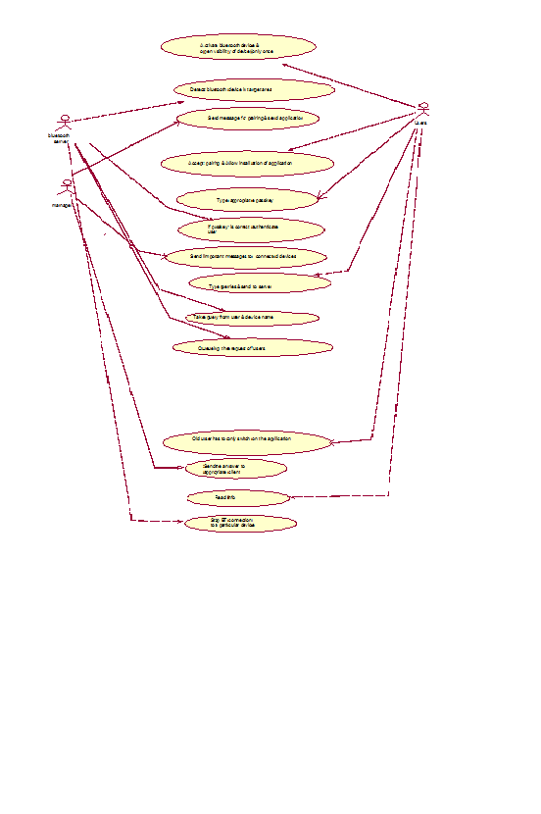

**PLAN OF ACTION**

**MODULE-1 :-**

Detail study of the concept and proof of concept

(July-Aug).

**MODULE-2:-**

Development of server for the system and basic android application

(Aug-Sep-Oct).

**MODULE-3:-**

Creation of Database and system (server) specific to a domain of

the computer.

(Oct-Nov-Dec)

**MODULE-4:-**

Enhancing the features of the android application feature like:

* + - Alerts
    - Billing Details
    - Maps
    - Schedules.

(Nov-Dec-Jan)

**MODULE-5:-**

Testing the complete client and server for all the possible options.

(Dec-Jan Feb)

**HARDWARE & SOFTWARE REQUIREMENT**

**SOFTWARE REQUIREMENT:**

* + JAVA JDK 1.7
  + Android SDK
  + Eclipse IDE
  + Apache tomcat 7.0
  + Mysql server 5.5
  + Navicat Premium
  + Blueclove 2.1.0
  + Android Emulator

**Hardware Requirements:**

* 2-Bluetooth 3.0 USB Dongles
* RAM 2GB
* HDD 500GB
* Intel i3 processor
* Internet conn.
* Android De

**REFERENCES**

* <http://seminarprojects.com/Thread-android-full-report#ixzz21LpFsD9H>
* <http://dspace.unimap.edu.my/dspace/bitstream/123456789/2911/5/Literature%20review.pdf>
* <http://www.bluetoothinformation.com/>
* <http://bluetoothprojects.blogspot.in/>